Assignment -04

**Comprehensive Study of Linux System Calls**

Linux system calls provide an interface between a program and the kernel, allowing user-level applications to request services from the operating system

1. Process Management System Calls

Process management system calls control the creation, execution, and termination of processes.

**Key System Calls:**

1. **fork()**
   * Creates a new process by duplicating the current process.
   * The new process is called the child process.
   * Returns 0 to the child process and the child's PID to the parent process.

**Example:**

**KeshavPorwal23I4143**

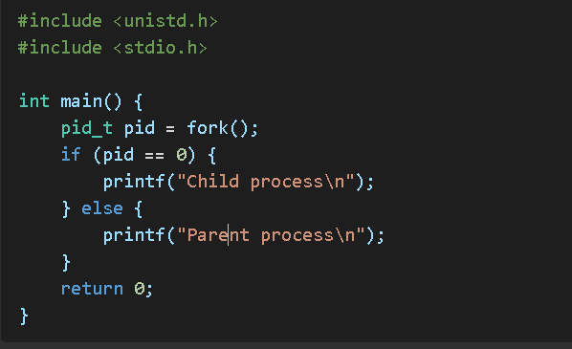

1. **exec()**

* Replaces the current process image with a new process image.
* Variants include execl, execv, execle, execve, etc.

**Example:**

**KeshavPorwal23I4143**

1. **wait()**

* Makes a parent process wait for its child to terminate.
* Returns the PID of the terminated child.

1. **exit()**

* Terminates the calling process.
* an exit status to the parent process.

**Example:**

**KeshavPorwal23I4143**

**2. File Management System Calls**

File management system calls handle file operations like creation, reading, writing, and closing files.

**Key System Calls:**

1. **open()**
   * Opens a file and returns a file descriptor.
   * Modes include O_RDONLY, O_WRONLY, O_RDWR.

**Example:**

**KeshavPorwal23I4143**

2. **read()**

* Reads data from a file descriptor into a buffer.

**Example:**

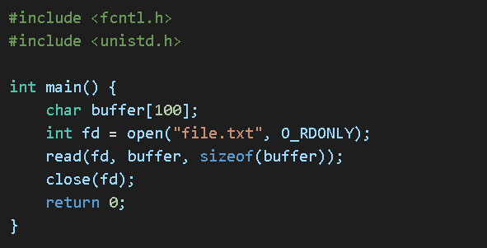

1. **write()**

* Writes data from a buffer to a file descriptor.

**Example:**

**KeshavPorwal23I4143**

**KeshavPorwal23I4143**

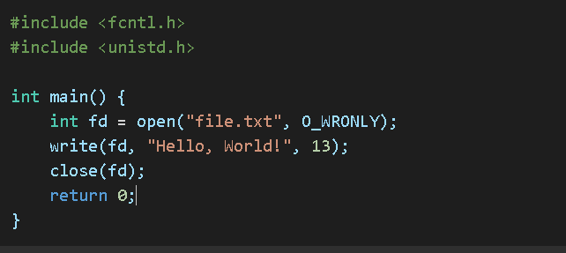

1. **close()**

* **Closes an open file descriptor.**

**Example:**

**3. Device Management System Calls**

Device management system calls manage input and output devices.

**Key System Calls:**

1. **read()**
   * Reads data from a device.
2. **write()**
   * Writes data to a device.
3. **ioctl()**
   * Performs device-specific operations.

**Example:**

1. **select()**

* Monitors multiple file descriptors.

**Example:**

**KeshavPorwal23I4143**

**KeshavPorwal23I4143**

**4. Network Management System Calls**

Network system calls facilitate communication between computers.

**Key System Calls:**

1. **socket()**
   * Creates a socket.

**Example:**

1. **connect()**
   * Connects a socket to a remote address.
2. **send()**
   * Sends data through a socket.
3. **recv()**
   * Receives data from a socket.

**5. System Information Management System Calls**

These calls retrieve system-related information.

**Key System Calls:**

1. **getpid()**
   * Gets the process ID.

**Example:**

**getuid() KeshavPorwal23I4143**

* + Gets the user ID.

1. **gethostname()**
   * Gets the hostname.
2. **sysinfo()**
   * Retrieves system statistics.

**Example:**

**KeshavPorwal23I4143**